Conditional specification
The phenomenon of conditional specification
A second mode of commitment involves interactions with neighboring cells. In this type of specification, each cell originally has the ability to become many different cell types. However, the interactions of the cell with other cells restricts the fate of one or both of the participants. This mode of commitment is sometimes called conditional specification, because the fate of a cell depends upon the conditions in which the cell finds itself. If a blastomere is removed from an early embryo that uses conditional specification, the remaining embryonic cells alter their fates so that the roles of the missing cells can be taken over. This ability of the embryonic cells to change their fates to compensate for the missing parts is called regulation (Figure 3.11). The isolated blastomere can also give rise to a wide variety of cell types (and sometimes generates cell types that the cell would normally not have made if it were part of the embryo). Thus, conditional specification gives rise to a pattern of embryogenesis called regulative development.‡ Regulative development is seen in most vertebrate embryos, and it is obviously critical in the development of identical twins. In the formation of such twins, the cleavage-stage cells of a single embryo divide into two groups, and each group of cells produces a fully developed individual (Figure 3.12).
The research leading to the discovery of conditional specification began with the testing of a hypothesis claiming that there was no such thing. In 1883, August Weismann proposed the first testable model of cell specification, the germ plasm theory. Based on the scant knowledge of fertilization available at that time, Weismann boldly proposed that the sperm and egg provided equal chromosomal contributions, both quantitatively and qualitatively, to the new organism. Moreover, he postulated that the chromosomes carried the inherited potentials of this new organism.§ However, not all the determinants on the chromosomes were thought to enter every cell of the embryo. Instead of dividing equally, the chromosomes were hypothesized to divide in such a way that different chromosomal determinants entered different cells. Whereas the fertilized egg would carry the full complement of determinants, certain somatic cells would retain the “blood-forming” determinants while others would retain the “muscle-forming” determinants (Figure 3.13). Only in the nuclei of those cells destined to become gametes (the germ cells) were all types of determinants thought to be retained. The nuclei of all other cells would have only a subset of the original determinant types.
In postulating this model, Weismann had proposed a hypothesis of development that could be tested immediately. Based on the fate map of the frog embryo, Weismann claimed that when the first cleavage division separated the future right half of the embryo from the future left half, there would be a separation of “right” determinants from “left” determinants in the resulting blastomeres. The testing of this hypothesis pioneered three of the four major techniques involved in experimental embryology:
• The defect experiment, wherein one destroys a portion of the embryo and then observes the development of the impaired embryo.
• The isolation experiment, wherein one removes a portion of the embryo and then observes the development of the partial embryo and the isolated part.
• The recombination experiment, wherein one observes the development of the embryo after replacing an original part with a part from a different region of the embryo.
• The transplantation experiment, wherein one portion of the embryo is replaced by a portion from a different embryo. This fourth technique was used by some of the same scientists when they first constructed fate maps of early embryos (see Chapter 1).
One of the first scientists to test Weismann's hypothesis was Wilhelm Roux, a young German embryologist. In 1888, Roux published the results of a series of defect experiments in which he took 2- and 4-cell frog embryos and destroyed some of the cells of each embryo with a hot needle. Weismann's hypothesis predicted the formation of right or left half-embryos. Roux obtained half-blastulae, just as Weismann had predicted (Figure 3.14). These developed into half-neurulae having a complete right or left side, with one neural fold, one ear pit, and so on. He therefore concluded that the frog embryo was a mosaic of self-differentiating parts and that it was likely that each cell received a specific set of determinants and differentiated accordingly.
Nobody appreciated Roux's work and the experimental approach to embryology more than Hans Driesch. Driesch's goal was to explain development in terms of the laws of physics and mathematics. His initial investigations were similar to those of Roux. However, while Roux's studies were defect experiments that answered the question of how the remaining blastomeres of an embryo would develop when a subset of them was destroyed, Driesch (1892) sought to extend this research by performing isolation experiments. He separated sea urchin blastomeres from each other by vigorous shaking (or, later, by placing them in calcium-free seawater). To Driesch's surprise, each of the blastomeres from a 2-cell embryo developed into a complete larva. Similarly, when Driesch separated the blastomeres from 4- and 8-cell embryos, some of the isolated cells produced entire pluteus larvae (Figure 3.15). Here was a result drastically different from the predictions of Weismann or Roux. Rather than self-differentiating into its future embryonic part, each isolated blastomere regulated its development so as to produce a complete organism. Moreover, these experiments provided the first experimentally observable instance of regulative development.
Driesch confirmed regulative development in sea urchin embryos by performing an intricate recombination experiment. In sea urchin eggs, the first two cleavage planes are meridional, passing through both the animal and vegetal poles, whereas the third division is equatorial, dividing the embryo into four upper and four lower cells. Driesch (1893) changed the direction of the third cleavage by gently compressing early embryos between two glass plates, thus causing the third division to be meridional like the preceding two. After he released the pressure, the fourth division was equatorial. This procedure reshuffled the nuclei, causing a nucleus that normally would be in the region destined to form endoderm to now be in the presumptive ectoderm region. Some nuclei that would normally have produced dorsal structures were now found in the ventral cells (Figure 3.16). If segregation of nuclear determinants had occurred (as had been proposed by Weismann and Roux), the resulting embryo should have been strangely disordered. However, Driesch obtained normal larvae from these embryos. He concluded, “The relative position of a blastomere within the whole will probably in a general way determine what shall come from it.”
The consequences of these experiments were momentous, both for embryology and for Driesch personally. First, Driesch had demonstrated that the prospective potency of an isolated blastomere (those cell types it was possible for it to form) is greater than its prospective fate (those cell types it would normally give rise to over the unaltered course of its development). According to Weismann and Roux, the prospective potency and the prospective fate of a blastomere should be identical. Second, Driesch concluded that the sea urchin embryo is a “harmonious equipotential system” because all of its potentially independent parts functioned together to form a single organism. Third, he concluded that the fate of a nucleus depended solely on its location in the embryo. Driesch (1894) hypothesized a series of events wherein development proceeded by the interactions of the nucleus and cytoplasm:
Insofar as it contains a nucleus, every cell, during development, carries the totality of all primordia; insofar as it contains a specific cytoplasmic cell body, it is specifically enabled by this to respond to specific effects only. . . .When nuclear material is activated, then, under its guidance, the cytoplasm of its cell that had first influenced the nucleus is in turn changed, and thus the basis is established for a new elementary process, which itself is not only the result but also a cause.
This strikingly modern concept of nuclear-cytoplasmic interaction and nuclear equivalence eventually caused Driesch to abandon science. Because the embryo could be subdivided into parts that were each capable of re-forming the entire organism, he could no longer envision it as a physical machine. In other words, Driesch had come to believe that development could not be explained by physical forces. Harking back to Aristotle, he invoked a vital force, entelechy (“internal goal-directed force”), to explain how development proceeds. Essentially, he believed that the embryo was imbued with an internal psyche and wisdom to accomplish its goals despite the obstacles embryologists placed in its path. Unable to explain his results in terms of the physics of his day, Driesch renounced the study of developmental physiology and became a philosophy professor, proclaiming vitalism (the doctrine that living things cannot be explained by physical forces alone) until his death in 1941. Others, especially Oscar Hertwig (1894), were able to incorporate Driesch's experiments into a more sophisticated experimental embryology.¶
The differences between Roux's experiments and those of Driesch are summarized in Table 3.4. The difference between isolation and defect experiments and the importance of the interactions among blastomeres were highlighted in 1910, when J. F. McClendon showed that isolated frog blastomeres behave just like separated sea urchin cells. Therefore, the mosaic-like development of the first two frog blastomeres in Roux's study was an artifact of the defect experiment. Something in or on the dead blastomere still informed the live cells that it existed. Therefore, even though Weismann and Roux pioneered the study of developmental physiology, their proposition that differentiation is caused by the segregation of nuclear determinants was soon shown to be incorrect.
The influence of neighboring cells
Driesch referred to the embryo as an “harmonious equipotential system” because each of the composite cells had surrendered most of its potential in order to form part of a single complete organism. Each cell could have become a complete animal on its own, yet didn't. What made the cells cooperate instead of becoming autonomous entities? Recent evidence suggests that the “harmonious equipotential system” is the result of negative induction events that mutually restrict the fates of neighboring cells. Jon Henry and colleagues in Rudolf Raff's laboratory (1989) showed that if one isolates pairs of cells from the animal cap of a 16-cell sea urchin embryo, those cells can give rise to both ectodermal and mesodermal components. However, their capacity to form mesoderm is severely restricted if they are aggregated with other animal cap pairs. Thus, the presence of neighbor cells, even of the same kind, restricts the potencies of both partners (Figure 3.17). Ettensohn and McClay (1988) and Khaner and Wilt 1990,1991 showed that potency is also restricted when a cell is combined with its neighbors along the animal-vegetal axis. First, they demonstrated that the number of skeletal mesoderm cells is fixed and can be regulated by changes in the cells that normally produce the gut endoderm. If all the 60 skeletal mesoderm cells of the sea urchin Lytechinus variegatus are removed from the early gastrula, an equal number of skeletal cells is produced from cells that would otherwisehave become part of the gut. If one removes 20 skeletal precursor cells, about 20 gut precursor cells become skeletal mesoderm. Thus, the skeletal mesoderm cells have a restrictive influence, preventing the formation of new skeletal mesoderm cells from the gut precursors.
Morphogen gradients
Cell fates may be specified by neighboring cells, but cell fates can also be specified by specific amounts of soluble molecules secreted at a distance from the target cells. Such a soluble molecule is called a morphogen, and a morphogen may specify more than one cell type by forming a concentration gradient. The concept of morphogen gradients had been used to model another phenomenon of regulative development: regeneration. It had been known since the 1700s that when hydras and planarian flatworms were cut in half, the head half would regenerate a tail from the wound site, while the tail half would regenerate a head. Allman (1864) had called attention to the fact that this phenomenon indicated a polarity in the organization of the hydra. It was not until 1905, however, that Thomas Hunt Morgan 1905,1906 realized that such polarity indicated an important principle in development. He pointed out that if the head and tail were both cut off a flatworm, leaving only the medial segment, this segment would regenerate a head from the former anterior end and a tail from the former posterior end— never the reverse (Figure 3.18A,B). Moreover, if the medial segment were sufficiently small, the regenerating portions would be abnormal (Figure 3.18C). Morgan postulated a gradient of anterior-producing materials concentrated in the head region. The middle segment would be told what to regenerate at both ends by the concentration gradient of these materials. If the piece were too small, however, the gradient would not be sensed within the segment. (It is possible that there are actually two gradients in the flatworm, one to instruct the formation of a head and one to instruct the production of a tail. Regeneration will be discussed in more detail in Chapter 18.)
In the 1930s through the 1950s, gradient models were used to explain conditional cell specification in sea urchin and amphibian embryos (Hörstadius and Wolsky 1936; Hörstadius 1939; Toivonen and Saxén 1955). In the 1960s, these gradient models were extended to explain how cells might be told their position along an embryonic axis (Lawrence 1966; Stumpf 1966; Wolpert (1968, 1969)). In such models, a soluble substance—the morphogen—is posited to diffuse from its site of synthesis (source) to its site of degradation (sink). Wolpert (1968) illustrated this type of positional information using “the French flag analogy.” Imagine a row of “flag cells,” each of which is capable of differentiating into a red, white, or blue cell. Then imagine a morphogen whose source is on the left-hand edge of the blue stripe, and whose sink is at the other end of the flag, on the right-hand edge of the red stripe. A concentration gradient is thus formed, being highest at one end of the “flag tissue” and lowest at the other. The specification of what type of cell any of the multipotential cells in this tissue will become is accomplished by the concentration of the morphogen. Cells sensing a high concentration of the morphogen become blue. Then there is a threshold of morphogen concentration below which cells become white. As the declining concentration of morphogen falls below another threshold, the cells become red (Figure 3.19).
Other tissues may use the same gradient system, but respond to the gradient in a different way. If cells that would normally become the middle segment of a Drosophila leg are removed from the leg-forming area of the larva and placed into the region that will become the tip of the fly's antenna, they differentiate into claws. These cells retain their committed status as leg cells, but respond to the positional information of their environment. Thereby, they became leg tip cells—claws. This phenomenon, said Wolpert, is analogous to reciprocally transplanting portions of American and French flags into each other. The segments will retain their identity (French or American), but will be positionally specified (develop colors) appropriate to their new positions.
The molecules involved in establishing such gradients are beginning to be identified. For a diffusible molecule to be considered a morphogen, it must be demonstrated that cells respond directly to that molecule and that the differentiation of those cells depends upon the concentration of that molecule. One such system currently being analyzed concerns the ability of different concentrations of the protein activin to specify different fates in the frog Xenopus. In the Xenopus blastula, the cells in the middle of the embryo become mesodermal by responding to activin (or an activin-like compound) produced in the vegetal hemisphere. Makoto Asashima and his colleagues (Fukui and Asashima 1994; Ariizumi and Asashima 1994) have shown that the animal cap of the Xenopus embryo (which normally becomes ectoderm, but which can be induced to form mesoderm if transplanted into other regions within the embryo) responds differently to different concentrations of activin. If left untreated in saline solution, animal cap blastomeres form an epidermis-like mass of cells. However, if exposed to small amounts of activin, they form ventral mesodermal tissue—blood and connective tissue. Progressively higher concentrations of activin will cause the animal cap cells to develop into other types of mesodermal cells: muscles, notochord cells, and heart cells (Figure 3.20).
John Gurdon's laboratory has shown that these animal cap cells respond to activin by changing the expression of particular genes (Figure 3.21; Gurdon et al. (1994,1995),). Gurdon and his colleagues placed activin-releasing beads or control beads into “sandwiches” of Xenopus animal cap cells. They found that cells exposed to little or no activin failed to express any of the genes associated with mesodermal tissues. These cells differentiated into ectoderm. Higher concentrations of activin turned on genes such as Brachyury, which are responsible for instructing cells to become mesoderm. Still higher concentrations of activin caused the cells to express genes such as goosecoid, which are associated with the most dorsal mesodermal structure, the notochord. The expression of the Brachyury and goosecoid genes has been correlated with the number of activin receptors on each cell that are bound by activin. Each cell has about 500 activin receptors. If about 100 of them are bound, this activates Brachyury expression, and the tissue becomes ventrolateral mesoderm, such as blood and connective tissue cells. If about 300 of these receptors are occupied, the cell turns on its goosecoid gene and differentiates into a more dorsal mesodermal cell type such as notochord (Figure 3.22; Dyson and Gurdon 1998; Shimizu and Gurdon 1999).
Morphogenetic fields
One of the most interesting ideas to come from experimental embryology has been that of the morphogenetic field. A morphogenetic field can be described as a group of cells whose position and fate are specified with respect to the same set of boundaries (Weiss 1939; Wolpert 1977). The general fate of a morphogenetic field is determined; thus, a particular field of cells will give rise to its particular organ (forelimb, eye, heart, etc.) even when transplanted to a different part of the embryo. However, the the individual cells within the field are not committed, and the cells of the field can regulate their fates to make up for missing cells in the field (Huxley and De Beer 1934; Opitz 1985; De Robertis et al. 1991). Moreover, as described earlier (i.e., the case of presumptive Drosophila leg cells transposed to the tip region of the presumptive antennal field), if cells from one field are placed within another field, they can use the positional cues of their new location, even if they retain their organ-specific commitment.
One of the first morphogenetic fields identified was the limb field. The mesodermal cells that give rise to a vertebrate limb can be identified by (1) removing certain groups of cells and observing that a limb does not develop in their absence (Detwiler 1918; Harrison 1918), (2) transplanting these cells to new locations and observing that they form a limb in this new place (Hertwig 1925), and (3) marking groups of cells with dyes or radioactive precursors and observing that their descendants partake in limb development (Rosenquist 1971). Figure 3.23 shows the prospective forelimb area in the tailbud stage of the salamander Ambystoma maculatum. The center of this disc normally gives rise to the limb itself. Adjacent to it are the cells that will form the peribrachial flank tissue and the shoulder girdle. However, if all these cells are extirpated from the embryo, a limb will still form, albeit somewhat later, from an additional ring of cells that surrounds this area (and which would not normally form a limb). If this last ring of cells is included in the extirpated tissue, no limb will develop. This larger region, representing all the cells in the area capable of forming a limb, is called the limb field.
When it first forms, the limb field has the ability to regulate for lost or added parts. In the tailbud stage of Ambystoma, any half of the limb disc is able to regenerate the entire limb when grafted to a new site (Harrison 1918). This potential can also be shown by splitting the limb disc vertically into two or more segments and placing thin barriers between the segments to prevent their reunion. When this is done, each segment develops into a full limb. The regulative ability of the limb bud has recently been highlighted by a remarkable experiment of nature. In several ponds in the United States, numerous multilegged frogs and salamanders have been found (Figure 3.24). The presence of these extra appendages has been linked to the infestation of the larval abdomen by parasitic trematode worms. The eggs of these worms apparently split the limb buds in several places while the tadpoles were first forming these structures (Sessions and Ruth 1990; Sessions et al. 1999). Thus, like an early sea urchin embryo, the limb field represents a “harmonious equipotential system” wherein a cell can be instructed to form any part of the limb.
The morphogenetic field has been referred to as a “field of organization” (Spemann 1921) and as a “cellular ecosystem” (1923, 1939). The ecosystem metaphor is quite appropriate, in that recent studies have shown that there are webs of interactions among the cells in different regions of a morphogenetic field. The molecular connections among the various cells of such fields are now being studied in the limb, eye, and heart fields of several vertebrates, as well as in the imaginal discs that form the eyes, antennae, legs, wings, and balancers of insects.
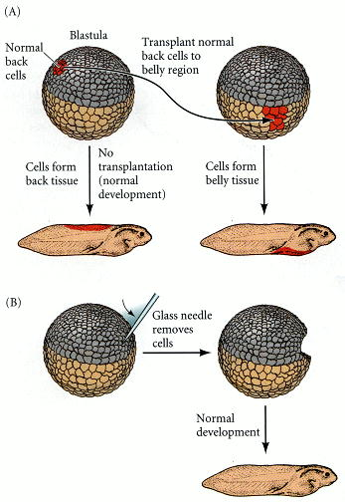
Figure 3.11. Conditional specification. (A) What a cell becomes depends upon its position in the embryo. Its fate is determined by interactions with neighboring cells. (B) If cells are removed from the embryo, the remaining cells can regulate and compensate for the missing part.
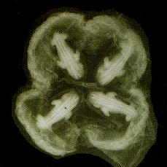
Figure 3.12. In the early developmental stages of many vertebrates, the separation of the embryonic cells into two parts can create twins. This phenomenon occurs sporadically in humans. However, in the nine-banded armadillo, Dasypus novemcinctus, the original embryo always splits into four separate groups of cells, each of which forms its own embryo. (Photograph courtesy of K. Benirschke.)
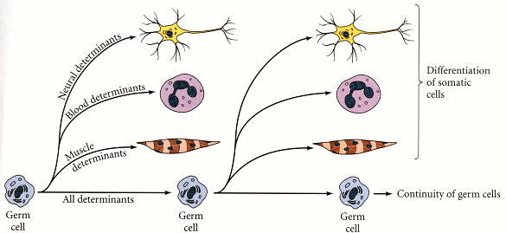
Figure 3.13. Weismann's theory of inheritance. The germ cell gives rise to the differentiating somatic cells of the body (indicated in color), as well as to new germ cells. Weismann hypothesized that only the germ cells contained all the inherited determinants. The somatic cells were each thought to contain a subset of the determinants. The types of determinants found in the nucleus would determine the cell type. (After Wilson 1896.)
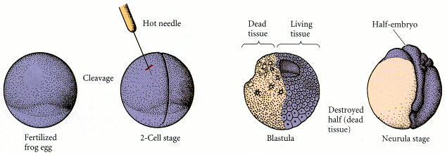
Figure 3.14. Roux's attempt to show mosaic development. Destroying (but not removing) one cell of a 2-cell frog embryo results in the development of only one-half of the embryo.
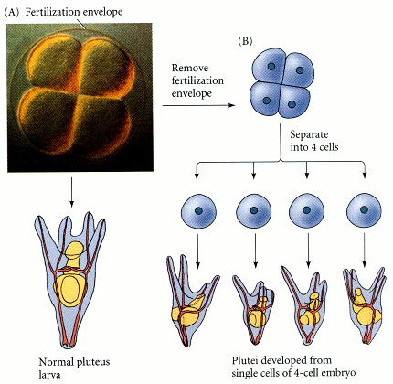
Figure 3.15. Driesch's demonstration of regulative development. (A) An intact 4-cell sea urchin embryo generates a normal pluteus larva. (B) When one removes the 4-cell embryo from its fertilization envelope and isolates each of the four cells, each cell can form a smaller, but normal, pluteus larva. (All larvae are drawn to the same scale.) Note that the four larvae derived in this way are not identical, despite their ability to generate all the necessary cell types. Such variations are also seen in adult sea urchins formed in this way (Marcus 1979). (Photograph courtesy of G. Watchmaker.)
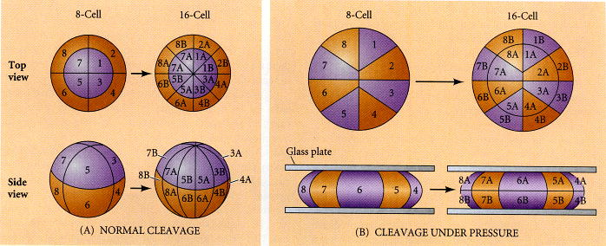
Figure 3.16. Driesch's pressure-plate experiment for altering the distribution of nuclei. (A) Normal cleavage in 8- to 16-cell sea urchin embryos, seen from the animal pole (upper sequence) and from the side (lower sequence). (B) Abnormal cleavage planes formed under pressure, as seen from the animal pole and from the side. (After Huxley and deBeer 1934.)

Table 3.4. Experimental procedures and results of Roux and Dreisch
Investigator | Organism | Type of experiment | Conclusion | Interpretation concerning potency and fate
Roux (1888) | Frog (Rana fusca) | Defect | Mosaic development (autonomous) | Prospective potency equals prospective fate
Driesch (1892) | Sea urchin (Echinus microtuberculatus) | Isolation | Regulative development (conditional) | Prospective potency is greater than prospective fate
Driesch (1893) | Sea urchin (Echinus and Paracentrotus) | Recombination | Regulative development (conditional) | Prospective potency is greater than prospective fate
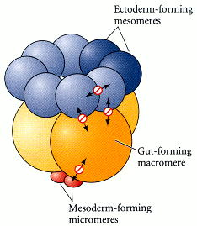
Figure 3.17. Summary of inhibitory interactions in the sea urchin blastula. Double-headed arrows illustrate the mutually restrictive interactions between adjacent cells. (After Henry et al. 1989.)
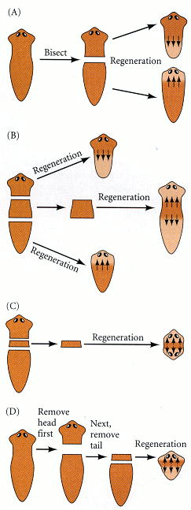
Figure 3.18. Flatworm regeneration and its limits. (A) If a flatworm is cut in two, the anterior portion of the bottom half regenerates a head, while the posterior of the upper half regenerates a tail. The same tissue can generate a head (if it is at the anterior portion of the tail piece) or a tail (if it at the posterior portion of the head piece). (B) If a flatworm is cut into three pieces, the middle piece will regenerate a head from its anterior end and a tail from its posterior end. (C) However, if the middle piece is too thin, there is no morphogen gradient within it, and regeneration is abnormal. (D) If the second cut is delayed, an equally thin middle section forms a normal worm, since the time lag has allowed an anterior-posterior gradient to become established. (After Gosse 1969.)
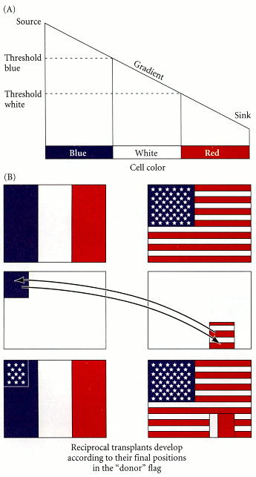
Figure 3.19. The French flag analogy for the operation of a gradient of positional information. (A) In this model, positional information is delivered by a gradient of a diffusible morphogen from a source to a sink. The thresholds indicated on the left are cellular properties that enable the gradient to be interpreted. For example, cells becomes blue at one concentration of the morphogen, but as the concentration declines below a certain threshold, cells become white. Where the concentration falls below another threshold, cells become red. The result is a pattern of three colors. (B) An important feature of this model is that a piece of tissue transplanted from one region of an embryo to another retains its identity (as to its origin), but differentiates according to its new positional instructions. This phenomenon is indicated schematically by reciprocal “grafts” between the flag of the United States of America and the French flag. (After Wolpert 1978.)

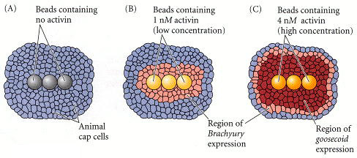
Figure 3.21. A gradient of activin causes different gene expression in Xenopus animal cap cells. The mRNAs from the Brachyury and goosecoid genes can be monitored by hybridization techniques that will be discussed in the next chapter. The cells containing these mRNAs appear darker than the cells not expressing them. Beads containing activin induce the expression (transcription of mRNA) of the Brachyury gene at distances removed from the beads. (A) Beads containing no activin did not elicit Brachyury gene expression. (B) Beads containing 1 nM activin elicited Brachyury expression near the beads. (C) Beads containing 4 nM activin elicited Brachyury gene expression several cell diameters away from the beads. However, goosecoid expression is seen where the concentration of activin is higher, near the source. Thus, it appears that Brachyury gene expression is induced at particular concentrations of activin, and that goosecoid is induced at higher concentrations of activin. (After Gurdon et al. 1994,1995.)

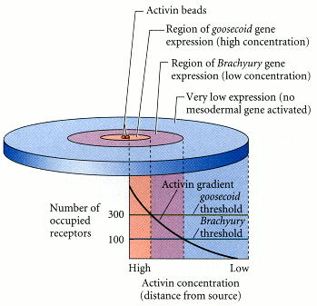
Figure 3.22. Interpretation of activin gradient by Xenopus animal cap cells. High concentrations of activin activate the goosecoid gene, while lower concentrations activate the Brachyury gene. This pattern correlates with the number of activin receptors occupied on the individual cells. A threshold value appears to exist that determines whether a cell will express goosecoid,Brachyury, or neither gene. (After Gurdon et al. 1998.)

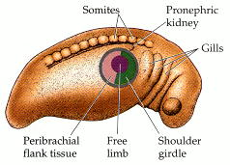
Figure 3.23. Prospective forelimb field of the salamander Ambystoma maculatum. The central area contains cells destined to form the limb per se (the free limb). The cells surrounding the free limb give rise to the peribrachial flank tissue and the shoulder girdle. The ring of cells outside these regions usually is not included the limb, but can form a limb if the more central tissues are extirpated. (After Stocum and Fallon 1983.)
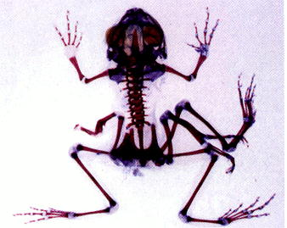
Figure 3.24. The regulative ability of the limb field as demonstrated by an experiment of nature. This multilimbed Pacific tree frog, Hyla regilla, is the result of infestation of the developing limb buds in the tadpole stage by trematode cysts. In this picture of the adult frog's skeleton, the cartilage is stained blue; the bones are stained red. (Courtesy of S. Sessions.)

